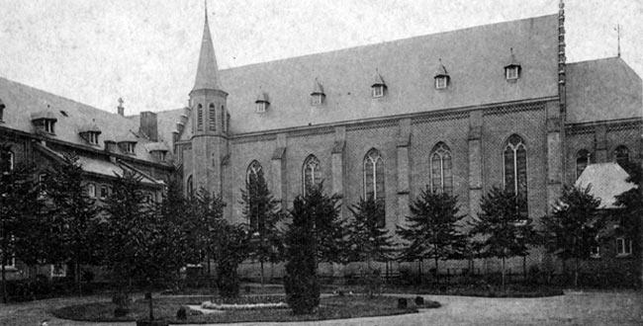
Heel, Netherlands

High child death rate in 1950s mental institution investigated
Published on : 17 August 2011 - 3:44pm | By Klaas den Tek (Photo: RNW)

The Dutch Public Prosecutor’s Office is investigating the cases of 34 mentally disabled youngsters who died whilst in the care of Roman Catholic clergy at the St Joseph care home in the southern province of Limburg at the beginning of the 1950s.
However, it has now also come to light that 40 girls at another Catholic home in the same town, Heel, also died in the period 1952 - 1954. In the case of these deaths, at the St Anna home for mentally disabled women, the girls were all aged 12 or younger, whilst the boys who died at St Joseph's were between 11 and 18.
No cause of death
The report about the deaths of the girls came from provincial broadcaster L1, which obtained the relevant figures from the municipal authorities under whose authority Heel now falls. The information does not include the exact causes of death.
A spokesperson for the municipality says “Many people believe the local council is notified of the cause of death. That isn’t always so. Sometimes there’s a report from a medical pathologist or a doctor, but in those days that kind of material was only kept for two years.”
So far the Public Prosecutor’s Office says it will not be launching a separate investigation into the seemingly high number of deaths at the girls' home. It says the information needs to be examined against the background of other information. The girls’ home had, for example, twice the number of inmates as the boys’ home, which could possibly explain the higher figure.
Abuse by clergy
The investigation into what actually happened at St Joseph's was prompted by information provided by the commission investigating abuses committed by Roman Catholic clergy. The Deetman commission – named after its head, former government minister Wim Deetman – sought access to the records of the boys’ home, which no longer exists, and discovered the unusually high death rate for the years in question.
Mr Deetman said: “There was silence when this came up in the commission. A certain despondency. All kinds of things go through your mind. What could have happened? Then you realise you can’t answer that question. It’s important that we find out what did happen, but perhaps we’ll never know.”
The Deetman commission has not raised any questions, so far, about the deaths at the girls’ home.
Cover-up
Relatives of boys who died at the home in Heel claim the Roman Catholic church has kept quiet about these cases for years. Some questions were raised by family members when some of the boys died at the home, but they normally met with a wall of silence. The diocese of Roermond, which encompasses Heel and the entire province of Limburg, has welcomed the launch of an investigation by the Public Prosecutor’s Office.
A spokesperson for the diocese was unable to explain why nothing happened in the past when relatives asked questions: “We talking about the 1950s. A totally different era […] I can only say that the Dutch bishops are in favour of [...] openness, and this is a good example of that. It was prompted by abuse, and we open up the archives for that.”
However, even if the enquiries do show that crimes were committed at the care home(s), no one will face prosecution because the deeds in question would fall under the Dutch statute of limitations. In other words, they took place too long ago for prosecution to take place under the Dutch criminal code. Nonetheless, given the social impact of the entire Roman Catholic abuse scandal, the Public Prosecutor’s Office wants to find out exactly what did happen at St Joseph’s in the 1950s.
http://www.rnw.nl/english/article/high-child-death-rate-1950s-mental-institution-investigated

